Step by Step Guide on how to use AmazonSmile:

Just visit www.smile.amazon.co.uk – rather than www.amazon.co.uk

If you already have an account with Amazon, your log in details will be the same for Amazon Smile – with all the same products and prices (the logo will just change in the top left hand corner!)

Under the search bar at the top, there is the text ‘Supporting: 'The Kent Autistic Trust’ – if yours doesn’t say this, simply click on the arrow to the right of the charity name, ‘Change your Charity’ and search for The Kent Autistic Trust.

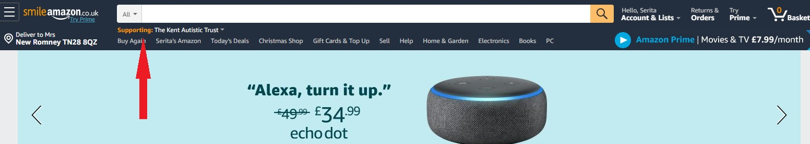
​

Every time you shop at AmazonSmile and choose The Kent Autistic Trust, you’re helping us support Autistic people across Kent.

Happy Shopping!!

